1. Install Splunk and create account
2. Log in using username and password

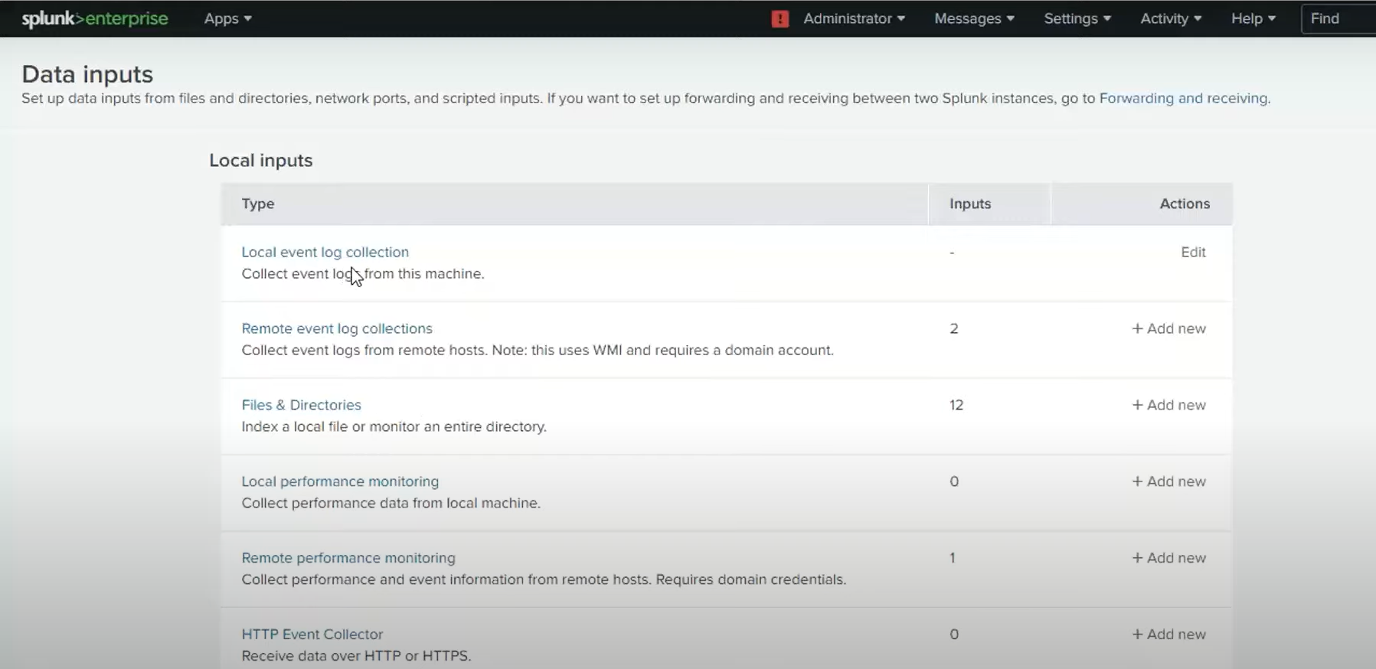

1. Click on files & directories. Muplitle data sources are available.

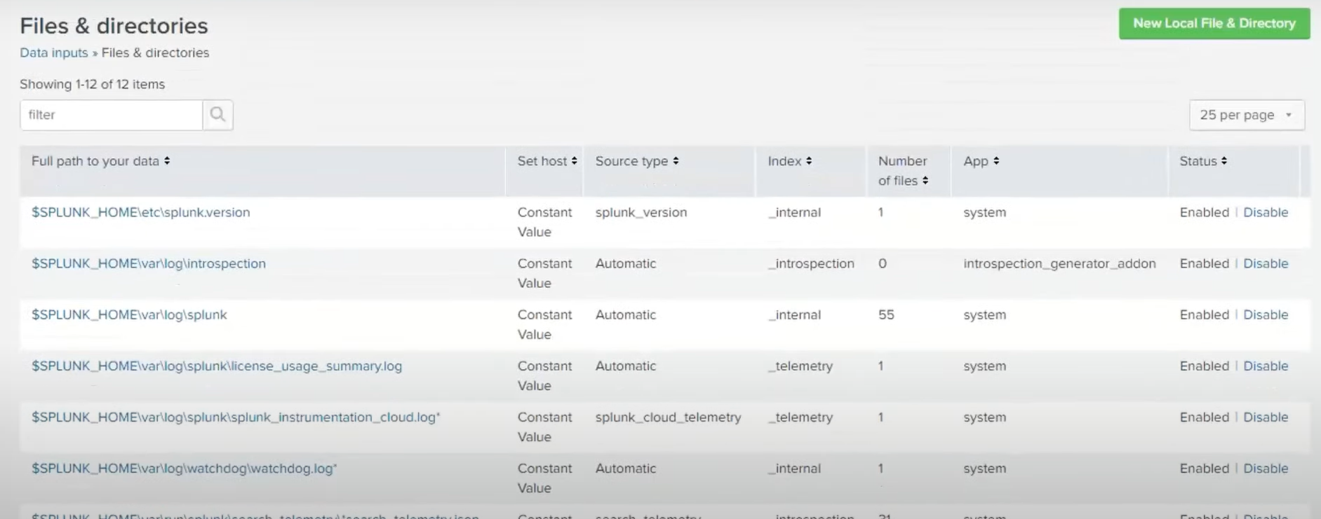

1. Click on new local file and directory and go to browse and select the file that you want to moniter (continuously monitor)
2. Click next and set source type and save it.

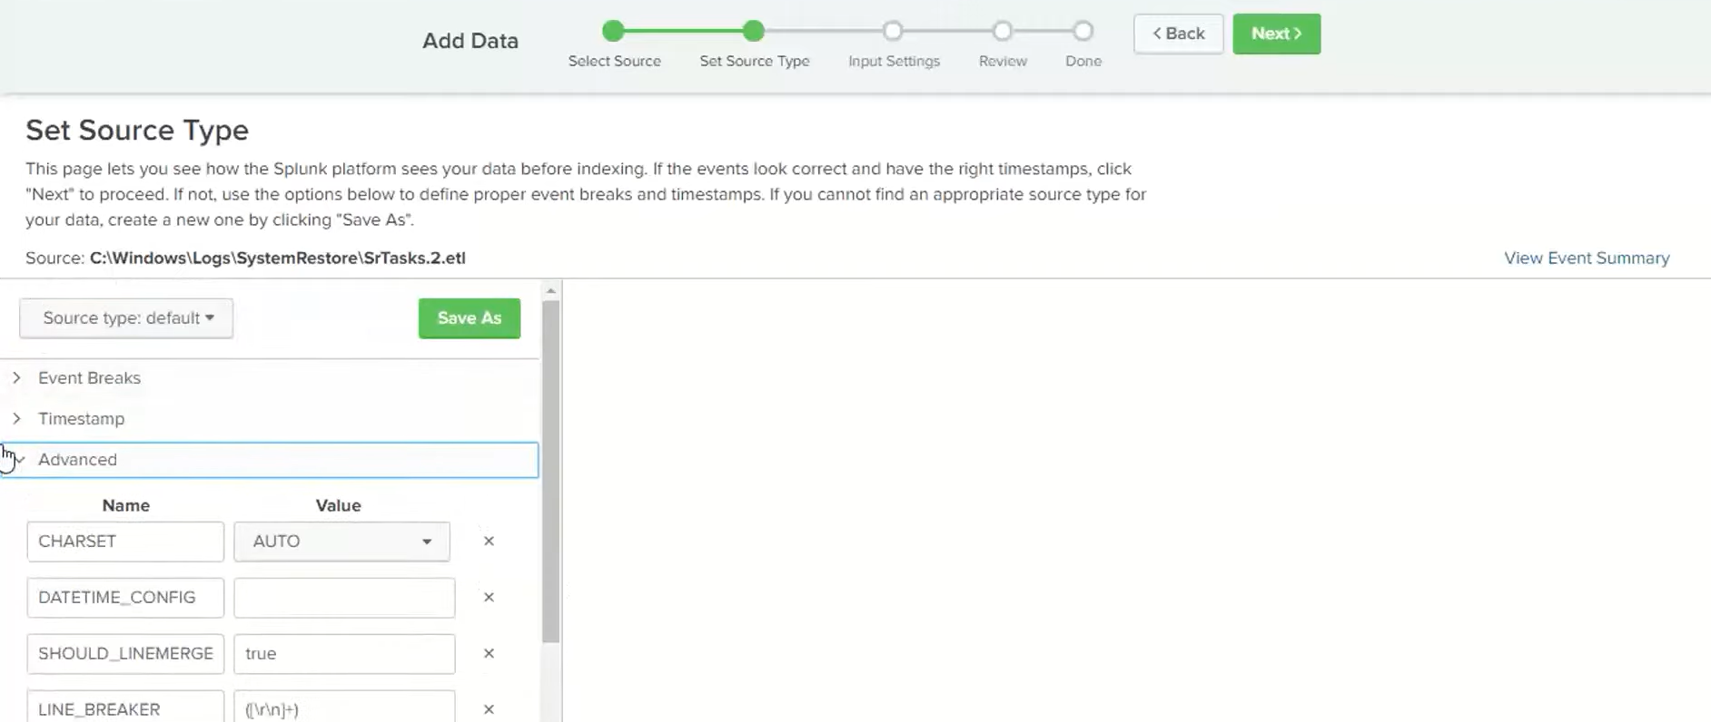

1. Move forward to Input settings: select the search and reporting option in app context.

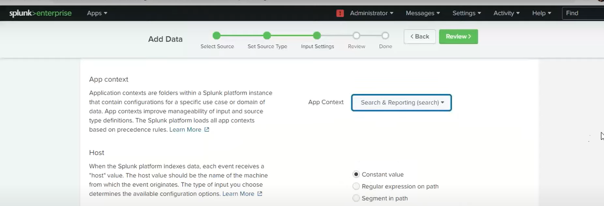

1. Create a new index, name it and then save.

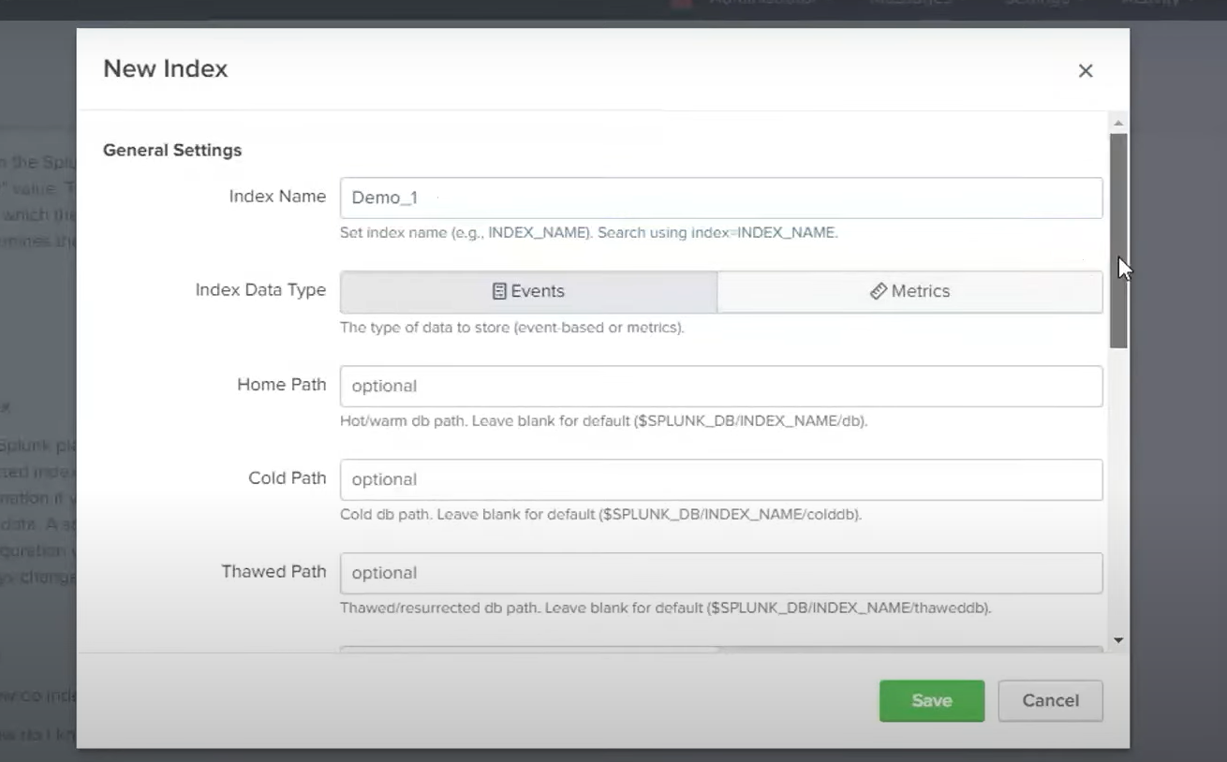

1. File input has been created successfully.
2. Search index

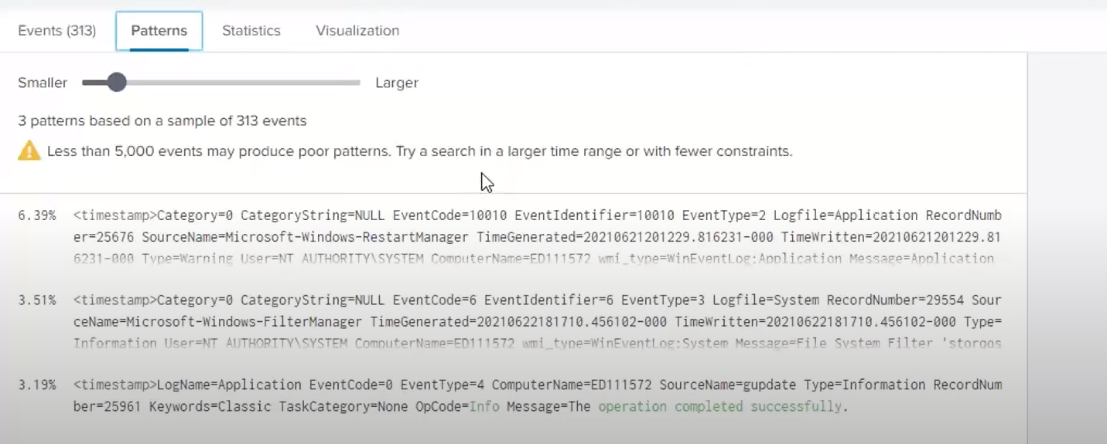



1. Go to statistics and then visualization

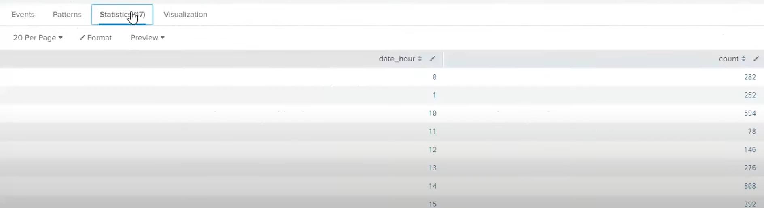

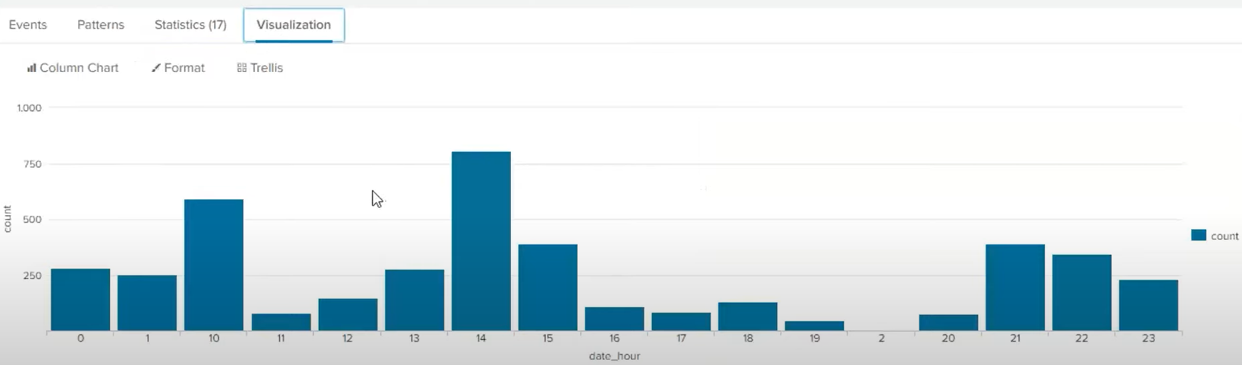



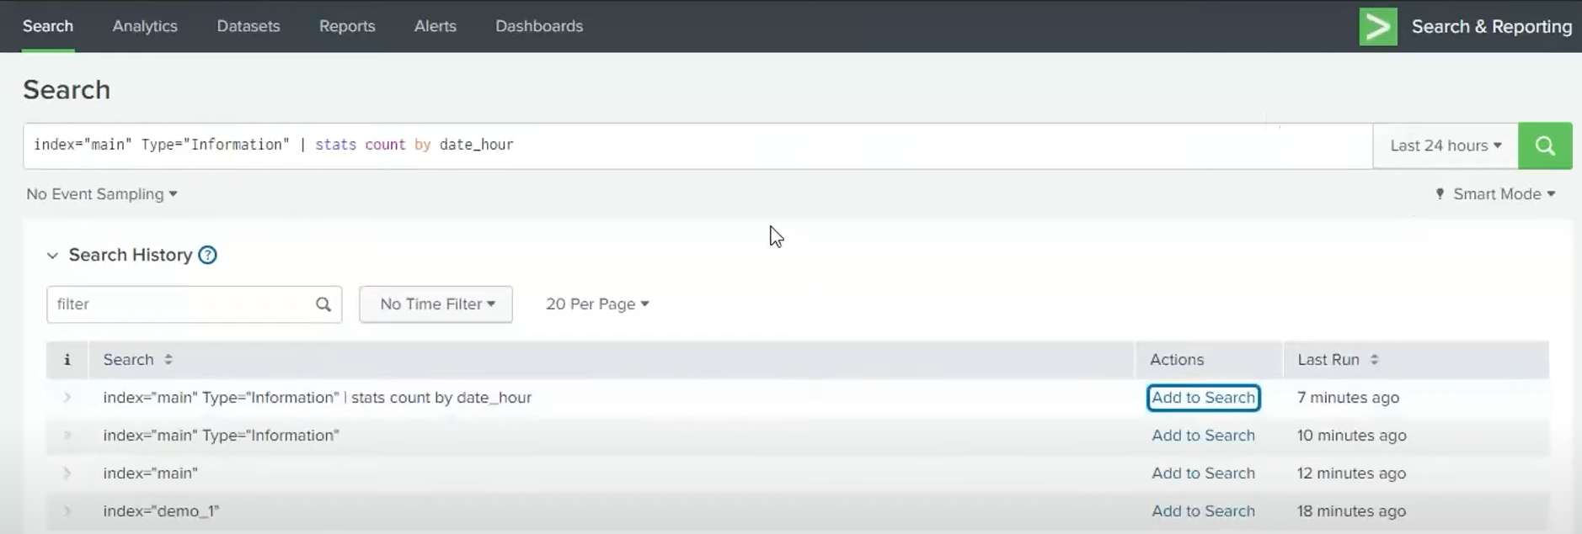

1. You can save them as Report, Alert, existing dashboard, new dashboard. We will save it as report.

